Republic of Zambia
Ministry of Education

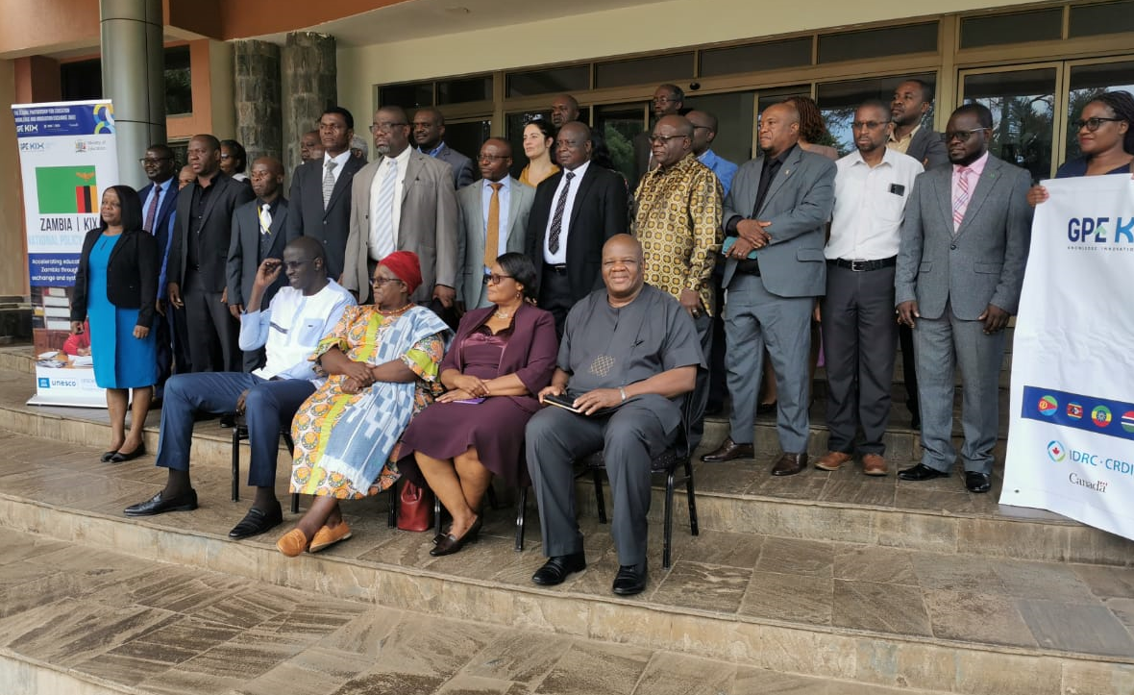
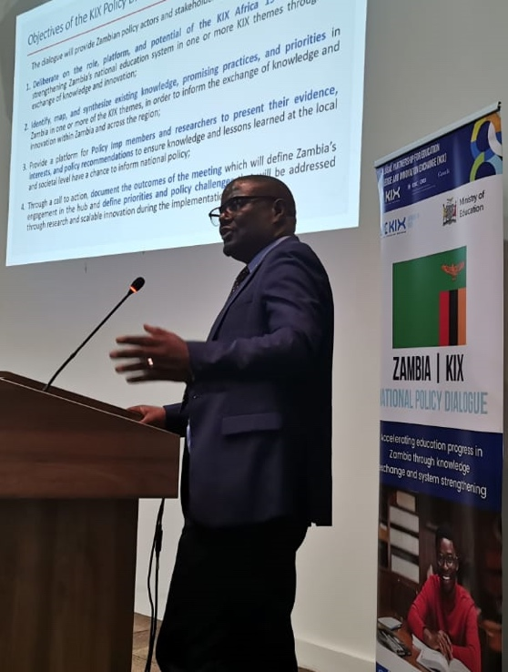
TWANGALE PARK – CHILANGA
27 NOVEMBER, 2023
KNOWLEDGE INNOVATION EXCHANGE (KIX) ZAMBIA NATIONAL POLICY DIALOUGE
CALL TO ACTION IN ZAMBIA

Table of Contents

1.0 INTRODUCTION 1

2.0 THEMATIC AREAS 3

2.1 Improving Teaching and Learning 3

2.2 Leaving no one behind 4

2.3 Meeting Data Challenge in Education: 5

Appendix 1 7

1.0 INTRODUCTION

Zambia has been a member of the Global Partnership for Education (GPE) Knowledge Innovation Exchange (KIX) Hub 19 for nearly four years. The country has participated effectively in the KIX hub activities locally and internationally. To foster national stakeholders' engagement and address the education sector’s many challenges, Zambia held a high-level national policy dialogue meeting facilitated by the United Nations Educational, Scientific and Cultural Organization (UNESCO) International Institute for Capacity Building in Africa (IICBA) on 27th November 2023 in Chilanga. UNESCO IICBA hosted the policy dialogue to foster a shared understanding of the roles and functions of the hub within the country to facilitate learning, collaboration, and capacity strengthening in critical areas of policy need.

Zambia’s policy dialogue meeting focused on three main themes, which included:

- Improving teaching and learning;
- leaving no one behind; and
- meeting the data challenge in education.

With the three key themes, the country envisions that the policy dialogue meeting will generate much needed discussion on sector priorities and result in strengthened learning partnerships, a synthesis of knowledge and priorities, and the documentation of evidence-based good practices that can be scaled throughout the country and shared with the other countries within the region.

The policy dialogue meeting allowed participants to engage with multiple presentations, review promising practices and determine gaps for providing quality teaching while ensuring that inclusivity was at the helm of education provision. The overall assessment from the meeting is that the MoE has data challenges coupled with a failure to develop and implement good practices in information management.

Nevertheless, participants observed that Zambia already has the good information and evidence it needs to enhance the performance of its national education system. For example, the country has consistently collected Grade 5 National Assessment data since 1999. Beyond the data issues, the policy dialogue meeting also addressed ways to invest in and sustain the production of Teaching and Learning Materials (TLMs).

Overall, the presenters and participants attending the policy dialogue meeting shared insightful and innovative contributions for the three thematic areas. In view of a well convened and productive meeting, participants felt strongly that academia and research efforts should continue to inform policy, and that evidence must be consistently, systematically, and effectively used for decision-making.

Accordingly, participants affirmed the importance of such dialogue meetings for exchanging knowledge and innovation at all levels of education provision in order to close gaps between policy and practice. As an important outcome of this exchange, the KIX Zambia National Dialogue members agreed to work towards improving attention to data and escalate synergies to bolster specific priorities using Zambia’s promising practices as a means for informed system wide scaling and transformation.

2.0 THEMATIC AREAS

In view of the above, the participants of the KIX Policy Dialogue agreed to prioritise the following:

2.1 Improving Teaching and Learning
(a) Provision of teaching and Learning materials to all learning institutions will be highly prioritised. These TLMs will be provided both by partners and the government. Schools will be encouraged to enhance locally made TLMs through capacity building by Zonal Insert Coordinators. As a way of fostering sustainability in the production of TLMs, the government should invest in Zambia Education Publishing House (ZEPH), conduct needs assessments and increase production so that all TLMs are produced locally.

(b) Strengthening Continuous Professional Development at all levels for both teachers and administrators. Participants agreed that Leadership and Management Training for school administrators will be enhanced. Teachers’ capacities in competency-based curriculum and learning should be strengthened to support learners in mastering skills and competencies accordingly. A discerning analysis by researchers highlighted a disjunction or misalignment between the intended curriculum and its practical enactment, amplifying the challenges confronting teachers. This disconnection emanates from the complex interplay between curriculum policies and the pragmatic complexities of the classroom settings. Consequently, teachers require ongoing and supportive CPD initiatives to effectively address the diverse learning needs of students within their respective educational contexts. Additionally, the catch-up methodology, aimed at optimizing teaching at the right level, will be enhanced to further contribute to the overall enhancement of educational practices.

(c) With the Education for All Policy impacting the learners, the participants agreed to equip, motivate, and inspire learners with innovative skills and competence that will propel social, economic, and national development to position Zambia as a credible participant in global development. To achieve this, the Ministry will employ various learning models to enhance the quality and relevance of education in line with the revised curriculum. Further, the Ministry will prioritise investment in science, technology, engineering, and mathematics (STEM).

(d) Strengthening community school engagement will also be on top of the agenda so that the Ministry explores more interventions aimed at returning learners in school through enhanced parent partnerships while improving the existing ones to promote schooling. When there is a sense of community and shared responsibility for education, students are more likely to attend school regularly and behave positively. This will reduce absenteeism, and dropouts and will create a supportive environment for learning. This will ensure learners maximise educational benefits and will improve attainment of learning outcomes.

2.2 Leaving No One Behind
(a) Presence, Participation and Achievements: Zambia subscribes to the principle of “All means ALL,” which implies that all learners have a right to an equal opportunity in education. Learners should access or be present in school (Right to Education); they should participate in all activities in and outside school (Right in Education); and they should achieve or benefit from the school system (Right through Education). In collaboration with other stakeholders, the participants at the KIX dialogue agreed to provide a least restrictive environment to actualise the tenets of Disability Inclusive Education.

(b) Human rights for all: In upholding Human rights for all, Disability Inclusion is a means for human dignity in education. First, a human being must be addressed, and the disability is secondary. The participants further prioritised the importance of combating discrimination and rising inequalities in education. The Right to Education is legally guaranteed for all without any discrimination. It is a commitment to end learning poverty, ensuring those left behind catch up to meet the Sustainable Development Goals (SDGs) 20230 targets. Accordingly, the GRZ has an obligation to protect, respect, and fulfil the Right to Education.

(c) Identification and Assessment: Leaving No One Behind hinges on equitable and inclusive education. Therefore, enhancing positive learner achievement and prioritising early identification and assessment of differently-abled learners is essential while improving teacher quality, assistive devices, and school instructional leadership. To achieve "leave no one behind", the school system will be strengthened to respond to all learners' needs adequately. This is a trajectory in achieving the inclusive education the education system needs.

(d) Management and Administration: Leaving no one behind will be strengthened by the school management and administration, especially in terms of assisting them to understand and implement the aforementioned priorities. Administrators who understand the value of educating learners with special educational needs or disability will be better placed to implement desirable practices. Therefore, providing educational management training for school administrators will be paramount.

(e) Infrastructure excellence: Participants agreed to establish the desired destination, which fosters a collaborative work culture aimed at taking every child on board. The education sector will strive to build on the successes and create more appropriate and adequate educational infrastructure, facilities, and equipment to facilitate the meaningful acquisition of knowledge, skills, and competencies amongst the learners while ensuring that differently-abled learners are catered to adequately.

2.3 Meeting Data Challenge in Education:

The participants resolved to: -

- take action to translate emerging good assessment practices into a policy directive that specifically reforms how teaching and learning is fostered and monitored;
- mandate rigorous requirements with regard to enhancing teacher skills in assessment practice at school (CDP)/college level;
- develop a policy and guidelines regarding the ethos of using learning data for decision-making, including setting performance targets;
- take policy action to solidify instructional leadership at all learning levels;
- Further build the capacity to collect, analyse and use the data sets for decision-making;
- Continue building the capacity to host databases and dashboards;
- Host data review meetings with stakeholders, set Key Performance Indicators (KPIs), and monitor and report on progress; and
- Collect, analyse and report on district and school profiles.

This call to action is a product of the commitments made by policy makers, the innovative information shared by the presenters, researchers, and Academia, and reactions of participants that include Teacher Unions, Cooperating partners and practitioners at the KIX Zambia National Dialogue held at Twangale Park – Chilanga. This, therefore, is a pledge to commit to these re-defined priorities in Zambia and a request for other education stakeholders in the country to follow suit and make their contributions in alignment with the three focus areas of KIX policy dialogue meeting.

Appendix 1

Participants for the Policy Dialogue

SN | Name | Position
1 | Ms. Daphine Chimuka | Chairperson - Teaching Service Commission
2 | Mr. Joel Kamoko | Permanent Secretary - Educational Services
3 | Mr. Saliou Sall | UNESCO IICBA
4 | Ms. Teza N. Musakanya | Examination Council of Zambia
5 | Mr. William Nyundu | Director Planning and Information
6 | Ms. Sibeso Mundia | Assistant Director Sector Pool
7 | Mr. James Chomba | Director Standards and Evaluation
8 | Dr. Beatrice Botha | Director Distance and Open Learning
9 | Dr. Charls Ndakala | Director Curriculum
10 | Mr. Charm Kalimbika | Director Early Childhood Education
11 | Mr. Kezala Mwale | Director Primary Education
12 | Ms. Yvonne Chuulu | Director Secondary Education
13 | Dr. Charles Zimba | Director ZEPH
14 | Mr. Mang’ombe Tembo | GPE/KIX FPP
15 | Dr. Heather Munachonga | NATCOM
16 | Mr. Chrispine Kabwe | Planner - Parliamentary Liaison Officer
17 | Ms. Chiluba Kabeli | Planner Budgets and Projects
18 | Mr. Nyambe Nambayi | JICA
19 | Ms. Shannon Taylor | USAID
20 | Mr. Terry Changwe | Assistant Director SE
21 | Ms. Yvonne Nyaluvwi | USAID
22 | Dr. Cornelius Chipoma | British Council
23 | Mr. Masauso Banda | World Bank
24 | Mr. George Hamusunga | ZANEC
25 | Ms. Miyanda Kambwa | IRISH AID
26 | Ms. Bweupe Njira | European Union
27 | Ms. Ikakena Namenda | CAMFED
28 | Ms. Esther Kambwa | Save the Children International
29 | Dr. Audrey Mwansa | TTE
30 | Dr. William Lapambwe | Consultant
31 | Dr. Robinson Mambwe | University of Zambia -
32 | Ms. Mukasami Mwanangombe | University of Lusaka
33 | Prof. Ackson M. Kanduza | Zambia Open University
34 | Dr. Nicholas Mwenya | Assistant Director TESS
35 | Mr. Sichamba Godfrey | Chalimbana University
36 | Mr. Alakwisa Phiri | ZNUT - Teacher Union
37 | Mr. Chisenga Gardner | SESTUZ - Teacher Union
38 | Ms. Chipo Chitola | UNITUZ - Teacher Union
39 | Mr. Sibetta Mooka | NUPPEZ - Teacher Union
40 | Mr. Lee Ndonyo | USAID
41 | Mr. Stephen Zimba | Principal Planner M&E
42 | Mr. Mooka Godfrey | Teacher Education and Specialised Services
43 | Ms. Chipo Kalinda | Planner
44 | Mr. Samuel Mutale | Senior Planner

